PIZZA SALES SQL QUERIES

1. **SELECT** SUM(total_price) AS Total_Revenue

**FROM** `pizza-sales-446307.pizza_sales.sales`

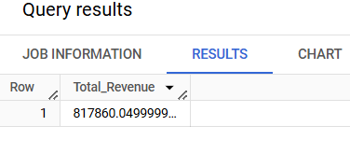

1. **SELECT** SUM(total_price)/COUNT(DISTINCT order_id) as Avg_order_value

**FROM** `pizza-sales-446307.pizza_sales.sales`

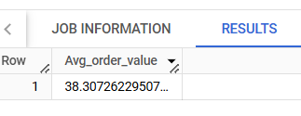

1. **SELECT** SUM(quantity) as Total_pizza_sold

**FROM** pizza-sales-446307.pizza_sales.sales

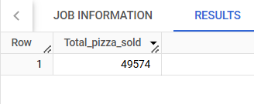

1. **SELECT** COUNT(DISTINCT order_id) as Total_orders

**FROM** pizza-sales-446307.pizza_sales.sales

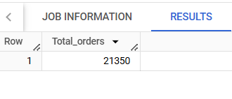

1. SELECT CAST(CAST(SUM(quantity) AS DECIMAL(10,2)) / CAST(COUNT(DISTINCT order_id) AS DECIMAL(10,2)) AS DECIMAL(10,2)) AS Avg_pizza_per_order

FROM pizza_sales

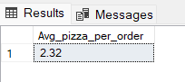

**DAILY TREND**

1. SELECT DATENAME(DW, order_date) as order_day, COUNT(DISTINCT order_id) as total_orders

FROM pizza_sales

GROUP BY DATENAME(DW, order_date)

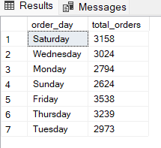

**HOURLY TREND**

1. SELECT DATEPART(HOUR, order_time) as order_hours, COUNT(DISTINCT order_id) as total_orders

FROM pizza_sales

GROUP BY DATEPART(HOUR, order_time)

ORDER BY DATEPART(HOUR, order_time)

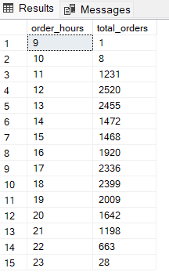

1. SELECT pizza_category, SUM(total_price) AS total_sales, SUM(total_price) * 100 / (SELECT SUM(total_price) from pizza_sales WHERE MONTH(order_date) = 1) AS PCT

FROM pizza_sales

WHERE MONTH(order_date) = 1

GROUP BY pizza_category

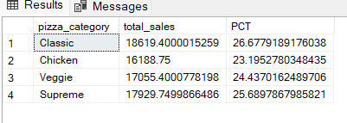

1. SELECT pizza_size, SUM(total_price) AS total_sales, SUM(total_price) * 100 / (SELECT SUM(total_price) from pizza_sales) AS PCT

FROM pizza_sales

GROUP BY pizza_size

ORDER BY PCT DESC

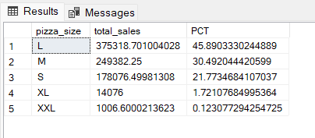

1. SELECT pizza_size, SUM(total_price) AS total_sales, SUM(total_price) * 100 / (SELECT SUM(total_price) from pizza_sales WHERE DATEPART(quarter, order_date) = 1) AS PCT

FROM pizza_sales

WHERE DATEPART(quarter, order_date) = 1

GROUP BY pizza_size

ORDER BY PCT DESC

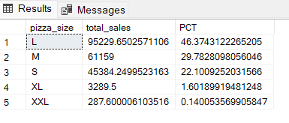

1. SELECT pizza_category, SUM(quantity) AS total_pizzas_sold

FROM pizza_sales

GROUP BY pizza_category

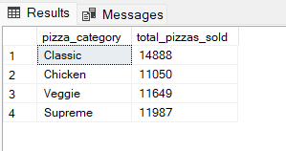

1. SELECT TOP 5 pizza_name, SUM(quantity) AS Total_pizzas_sold

FROM pizza_sales

GROUP BY pizza_name

ORDER BY SUM(quantity) DESC

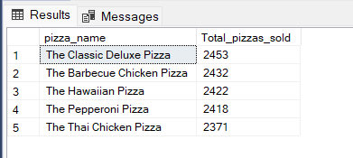

1. SELECT TOP 5 pizza_name, SUM(quantity) AS Total_pizzas_sold

FROM pizza_sales

GROUP BY pizza_name

ORDER BY SUM(quantity)

